
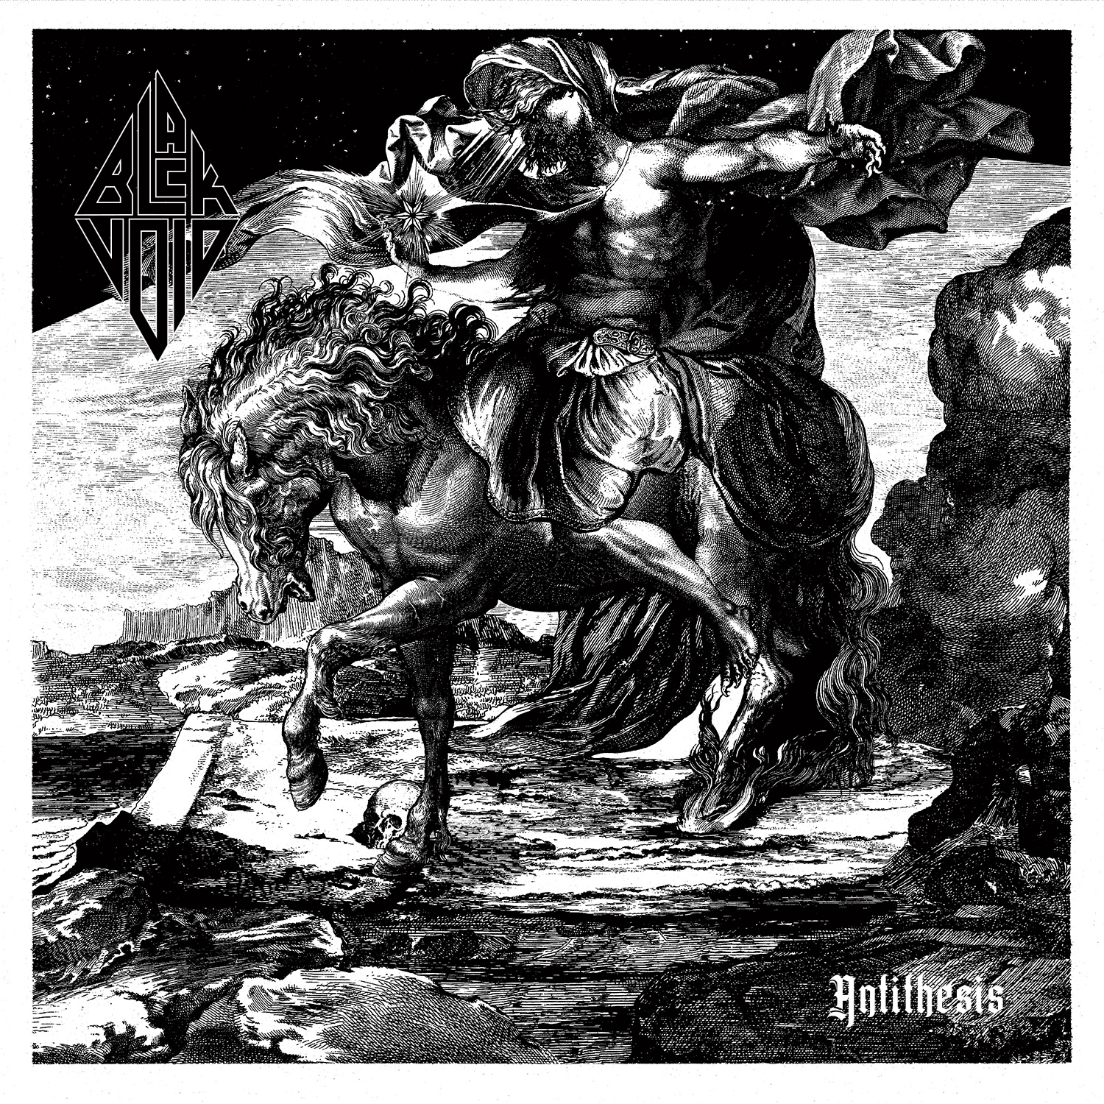

BLACK VOID
»Antithesis«

OUT: May 27th, 2022

Line up:

Line up:
Jostein Thomassen - Guitars
Tobias Øymo Solbakk - Drums
Lars Are Nedland – Vocals and bass

There is nothing!
No MORALITY!
No KNOWLEDGE!
No GOD!
No MEANING!

BLACK VOID is nihilistic aggression and desperation in the form of music. Furious and unrepentant in attitude, it builds on the philosophical works of Friedrich Nietzsche, burning with the filthy flame of punk and black metal.

“When it’s impossible to find a starting point for knowledge, how can there be any kind of ethics? How can anyone argue that morality exists?
How can we claim to know anything at all?”

In the midst of this dirty metaphysical whirlwind stands vocalist and bass player Lars Are Nedland, long-time member of BORKNAGAR and SOLEFALD, and the driving force of melodic hard rock band WHITE VOID. Spearheading a trio completed by drummer Tobias Solbakk (IHSAHN, WHITE VOID, IN VAIN) and guitarist Jostein Thomassen (BORKNAGAR, PROFANE BURIAL), he sets the stage for BLACK VOID to be everything that WHITE VOID is not: Monochrome, nihilistic, filthy, violent and raw.

“Life should be rejected
Death should be rejected
It all should be rejected”

BLACK VOID, then, is the flipside of WHITE VOID: A full-on rejection of the philosophy of Albert Camus, a full-on rejection of a soft, melodic approach in music and a full-on rejection of a playful, tongue-in-cheek attitude. BLACK VOID has the sensitivity of a buzz-saw and the light-heartedness of a funeral agent. With that as a backdrop, “Antithesis” becomes an album that pays respect to fifty years of punk and forty years of black metal, sounding like a punk with a Mohawk fighting a dude in corpse paint as it races along.

Add to that guest vocal appearances by black metal royalties Sakis Tolis of ROTTING CHRIST and Hoest of TAAKE, “Antithesis” appears as a statement of sorts: A nihilistic musical outburst flipping off morality and hailing aggression while at the same time forcing your foot to tap to its relentless drive. It’s all in the black and white.

1. Void 4:23
2. Reject Everything 4:48
3. Death to Morality 5:03
4. Tenebrism of Life 4:16
5. No Right, No Wrong 4:09
6. It's not Surgery, it's a Knife Fight 4:32
7. Explode into Nothingness 3:21
8. Nihil 3:28
9. Dadaist Disgust 4:24
Total playing time: 38:24

“Antithesis” was written and recorded between
2019 and 2021
Mixed and mastered by Øystein G. Brun at Crosound Studio
Drums engineered and recorded by Tobias Øymo Solbakk at Splinter Studios
Bass, vocals and keys engineered and recorded by Lars Are Nedland at Mezzanine Studios
Guitars engineered and recorded by Jostein Thomassen at Riff Sheriff Studio
Keys played by Lars Are Nedland

----
All music written by Lars Are Nedland
All lyrics written by Lars Are Nedland

All songs arranged by BLACK VOID

Produced by Øystein G. Brun and Lars Are Nedland

Guest vocals on ‘Death to Morality’
by Hoest of TAAKE

Guest vocals on ‘Dadaist Disgust’
by Sakis Tolis of ROTTING CHRIST

Layout and design by Trine + Kim Design Studio
Cover painting by Artem Grigoryev
Band photos by Jørn Veberg

